TechConnect

Locaberte, Leynard A.

Miranda, Abegail C.

Endozo, Jasmine S.

Algorithm and Data Analysis

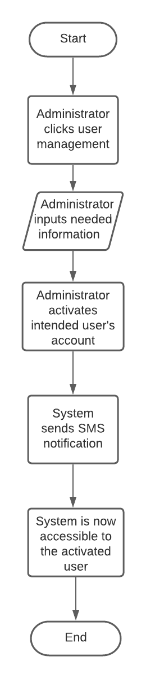

As the system administrator enters the user management, he/ she gathers information about the calamity and activates user’s account within the affected area. The system generates calamity response alert and SMS notification for their account activation. The intended user can now access the system.